鼎基先進
10G Switch 設定
(config)

Login 10G Switch
ssh 192.168.10.63 & 192.168.10.64
User:admin
Password:admin
DZSAPSW1#
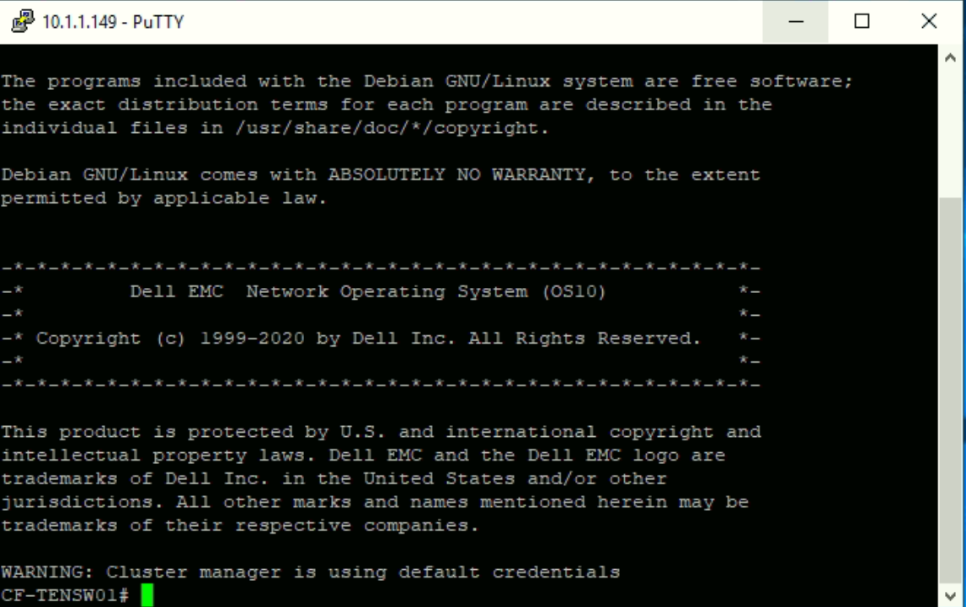

Set Stack(兩台Switch做堆疊，使用te1/1/25、te1/1/26作為堆疊port)
先登入第一台10g Switch作設定  S1# configure terminal  S1(config)# spanning-tree mode rstp  S1(config)# spanning-tree rstp priority 4096  S1(config)# interface range e1/1/25-1/1/26  S1(conf-range-eth1/1/25-1/1/26)# no switchport  S1(conf-range-eth1/1/25-1/1/26)# no shutdown  S1(conf-range-eth1/1/25-1/1/26)# exit  S1 (config)# interface mgmt 1/1/1  S1 (conf-if-ma-1/1/1)# no ip address dhcp  S1 (conf-if-ma-1/1/1)# ip address 192.168.10.63/24  S1 (conf-if-ma-1/1/1)# no shutdown  S1 (conf-if-ma-1/1/1)#exit  S1(config)# vlt-domain 1  S1(conf-vlt-1)# discovery-interface ethernet 1/1/25  S1(conf-vlt-1)# discovery-interface ethernet 1/1/26  S1(conf-vlt-1)# vlt-mac 0a:0b:0c:dd:dd:ff  S1(conf-vlt-1)# backup destination 192.168.10.64  S1(conf-vlt-1)# delay-restore 10  S1(conf-vlt-1)# peer-routing  S1(conf-vlt-1)#exit  S1(config)# interface port-channel 1  S1(conf-if-po-1)# description "Connect to S2 switch"  S1(conf-if-po-1)# vlt-port-channel 1  *S1(conf-if-po-1)# switchport mode trunk  *S1(conf-if-po-1)# switchport trunk allowed vlan 10  S1(conf-if-po-1)# no shutdown  S1(conf-if-po-1)# exit  *S1(config)# interface ethernet e1/1/29  *S1(conf-range-eth1/1/29)# channel-group 1 mode active  *S1(conf-range-eth1/1/29)# no shutdown  *S1(conf-range-eth1/1/29)# exit | 登入第二台10g Switch作設定  S2# configure terminal  S2(config)# spanning-tree mode rstp  S2(config)# spanning-tree rstp priority 4096  S2(config)# interface range e1/1/25-1/1/26  S2(conf-range-eth1/1/25-1/1/26)# no switchport  S2(conf-range-eth1/1/25-1/1/26)# no shutdown  S2(conf-range-eth1/1/25-1/1/26)# exit  S2 (config)# interface mgmt 1/1/1  S2 (conf-if-ma-1/1/1)# no ip address dhcp  S2 (conf-if-ma-1/1/1)# ip address 192.168.10.63/24  S2 (conf-if-ma-1/1/1)# no shutdown  S2 (conf-if-ma-1/1/1)#exit  S2(config)# vlt-domain 1  S2(conf-vlt-1)# discovery-interface ethernet 1/1/25  S2(conf-vlt-1)# discovery-interface ethernet 1/1/26  S2(conf-vlt-1)# vlt-mac 0a:0b:0c:dd:dd:ff  S2(conf-vlt-1)# backup destination 192.168.10.63  S2(conf-vlt-1)# delay-restore 10  S2(conf-vlt-1)# peer-routing  S2(conf-vlt-1)#exit  S2(config)# interface port-channel 1  S2(conf-if-po-1)# description "Connect to S1 switch"  S2(conf-if-po-1)# vlt-port-channel 1  *S2(conf-if-po-1)# switchport mode trunk  *S2(conf-if-po-1)# switchport trunk allowed vlan 10  S2(conf-if-po-1)# no shutdown  S2(conf-if-po-1)# exit  *S2(config)# interface ethernet e1/1/29  *S2(conf-range-eth1/1/29)# channel-group 1 mode active  *S2(conf-range-eth1/1/29)# no shutdown  *S2(conf-range-eth1/1/29)# exit

Show running-config(查看執行設定檔)
DZSAPSW1# show running-configuration 查看使用中設定檔 | DZSAPSW2# show running-configuration 查看使用中設定檔
DZSAPSW1# show running-configuration  ! Version 10.5.0.4  ! Last configuration change at Jan 13 15:25:26 2021  !  ip vrf default  !  interface breakout 1/1/25 map 100g-1x  interface breakout 1/1/26 map 100g-1x  hostname DZSAPSW1  iscsi enable  iscsi target port 860  iscsi target port 3260  system-user linuxadmin password $6$5DdOHYg5$JCE1vMSmkQOrbh31U74PIPv7lyOgRmba1IxhkYibppMXs1KM4Y.gbTPcxyMP/PHUkMc5rdk/ZLv9Sfv3ALtB61  spanning-tree mode rstp  spanning-tree rstp priority 4096  username admin password $6$q9QBeYjZ$jfxzVqGhkxX3smxJSH9DDz7/3OJc6m5wjF8nnLD7/VKx8SloIhp4NoGZs0I/UNwh8WVuxwfd9q4pWIgNs5BKH. role sysadmin priv-lvl 15  aaa authentication login default local  aaa authentication login console local  !  class-map type application class-iscsi  !  policy-map type application policy-iscsi  !  interface vlan1  no shutdown  !  interface port-channel1  description "Connection to S3 Switch"  no shutdown  switchport access vlan 1  vlt-port-channel 1  !  interface mgmt1/1/1  no shutdown  no ip address dhcp  ip address 192.168.10.63/24  !  interface ethernet1/1/1  no shutdown  switchport access vlan 1  flowcontrol receive on  !  interface ethernet1/1/2  no shutdown  switchport access vlan 1  flowcontrol receive on  !  interface ethernet1/1/3  no shutdown  switchport access vlan 1  flowcontrol receive on  !  interface ethernet1/1/4  no shutdown  switchport access vlan 1  flowcontrol receive on  !  interface ethernet1/1/5  no shutdown  switchport access vlan 1  flowcontrol receive on  !  interface ethernet1/1/6  no shutdown  switchport access vlan 1  flowcontrol receive on  !  interface ethernet1/1/7  no shutdown  switchport access vlan 1  flowcontrol receive on  !  interface ethernet1/1/8  no shutdown  switchport access vlan 1  flowcontrol receive on  !  interface ethernet1/1/9  no shutdown  switchport access vlan 1  flowcontrol receive on  !  interface ethernet1/1/10  no shutdown  switchport access vlan 1  flowcontrol receive on  !  interface ethernet1/1/11  no shutdown  switchport access vlan 1  flowcontrol receive on  !  interface ethernet1/1/12  no shutdown  switchport access vlan 1  flowcontrol receive on  !  interface ethernet1/1/13  no shutdown  switchport access vlan 1  flowcontrol receive on  !  interface ethernet1/1/14  no shutdown  switchport access vlan 1  flowcontrol receive on  !  interface ethernet1/1/15  no shutdown  switchport access vlan 1  flowcontrol receive on  !  interface ethernet1/1/16  no shutdown  switchport access vlan 1  flowcontrol receive on  !  interface ethernet1/1/17  no shutdown  switchport access vlan 1  flowcontrol receive on  !  interface ethernet1/1/18  no shutdown  switchport access vlan 1  flowcontrol receive on  !  interface ethernet1/1/19  no shutdown  switchport access vlan 1  flowcontrol receive on  !  interface ethernet1/1/20  no shutdown  switchport access vlan 1  flowcontrol receive on  !  interface ethernet1/1/21  no shutdown  switchport access vlan 1  flowcontrol receive on  !  interface ethernet1/1/22  no shutdown  switchport access vlan 1  flowcontrol receive on  !  interface ethernet1/1/23  no shutdown  switchport access vlan 1  flowcontrol receive on  !  interface ethernet1/1/24  no shutdown  switchport access vlan 1  flowcontrol receive on  !  interface ethernet1/1/25  no shutdown  no switchport  flowcontrol receive on  !  interface ethernet1/1/26  no shutdown  no switchport  flowcontrol receive on  !  interface ethernet1/1/27  no shutdown  switchport access vlan 1  flowcontrol receive on  !  interface ethernet1/1/28  no shutdown  switchport access vlan 1  flowcontrol receive on  !  interface ethernet1/1/29  no shutdown  switchport access vlan 1  flowcontrol receive on  !  interface ethernet1/1/30  no shutdown  switchport access vlan 1  flowcontrol receive on  !  vlt-domain 1  backup destination 192.168.10.64  delay-restore 10  discovery-interface ethernet1/1/25-1/1/26  peer-routing  vlt-mac 0a:0b:0c:dd:dd:ff  !  snmp-server contact "Contact Support"  !  telemetry  DZSAPSW1# | DZSAPSW2# show running-configuration  ! Version 10.5.0.4  ! Last configuration change at Jan 13 15:17:53 2021  !  ip vrf default  !  interface breakout 1/1/25 map 100g-1x  interface breakout 1/1/26 map 100g-1x  hostname DZSAPSW2  iscsi enable  iscsi target port 860  iscsi target port 3260  system-user linuxadmin password $6$5DdOHYg5$JCE1vMSmkQOrbh31U74PIPv7lyOgRmba1IxhkYibppMXs1KM4Y.gbTPcxyMP/PHUkMc5rdk/ZLv9Sfv3ALtB61  spanning-tree mode rstp  spanning-tree rstp priority 8192  username admin password $6$q9QBeYjZ$jfxzVqGhkxX3smxJSH9DDz7/3OJc6m5wjF8nnLD7/VKx8SloIhp4NoGZs0I/UNwh8WVuxwfd9q4pWIgNs5BKH. role sysadmin priv-lvl 15  aaa authentication login default local  aaa authentication login console local  !  class-map type application class-iscsi  !  policy-map type application policy-iscsi  !  interface vlan1  no shutdown  !  interface port-channel1  description "Connection to S1 Switch"  no shutdown  switchport access vlan 1  vlt-port-channel 1  !  interface mgmt1/1/1  no shutdown  no ip address dhcp  ip address 192.168.10.64/24  !  interface ethernet1/1/1  no shutdown  switchport access vlan 1  flowcontrol receive on  !  interface ethernet1/1/2  no shutdown  switchport access vlan 1  flowcontrol receive on  !  interface ethernet1/1/3  no shutdown  switchport access vlan 1  flowcontrol receive on  !  interface ethernet1/1/4  no shutdown  switchport access vlan 1  flowcontrol receive on  !  interface ethernet1/1/5  no shutdown  switchport access vlan 1  flowcontrol receive on  !  interface ethernet1/1/6  no shutdown  switchport access vlan 1  flowcontrol receive on  !  interface ethernet1/1/7  no shutdown  switchport access vlan 1  flowcontrol receive on  !  interface ethernet1/1/8  no shutdown  switchport access vlan 1  flowcontrol receive on  !  interface ethernet1/1/9  no shutdown  switchport access vlan 1  flowcontrol receive on  !  interface ethernet1/1/10  no shutdown  switchport access vlan 1  flowcontrol receive on  !  interface ethernet1/1/11  no shutdown  switchport access vlan 1  flowcontrol receive on  !  interface ethernet1/1/12  no shutdown  switchport access vlan 1  flowcontrol receive on  !  interface ethernet1/1/13  no shutdown  switchport access vlan 1  flowcontrol receive on  !  interface ethernet1/1/14  no shutdown  switchport access vlan 1  flowcontrol receive on  !  interface ethernet1/1/15  no shutdown  switchport access vlan 1  flowcontrol receive on  !  interface ethernet1/1/16  no shutdown  switchport access vlan 1  flowcontrol receive on  !  interface ethernet1/1/17  no shutdown  switchport access vlan 1  flowcontrol receive on  !  interface ethernet1/1/18  no shutdown  switchport access vlan 1  flowcontrol receive on  !  interface ethernet1/1/19  no shutdown  switchport access vlan 1  flowcontrol receive on  !  interface ethernet1/1/20  no shutdown  switchport access vlan 1  flowcontrol receive on  !  interface ethernet1/1/21  no shutdown  switchport access vlan 1  flowcontrol receive on  !  interface ethernet1/1/22  no shutdown  switchport access vlan 1  flowcontrol receive on  !  interface ethernet1/1/23  no shutdown  switchport access vlan 1  flowcontrol receive on  !  interface ethernet1/1/24  no shutdown  switchport access vlan 1  flowcontrol receive on  !  interface ethernet1/1/25  no shutdown  no switchport  flowcontrol receive on  !  interface ethernet1/1/26  no shutdown  no switchport  flowcontrol receive on  !  interface ethernet1/1/27  no shutdown  switchport access vlan 1  flowcontrol receive on  !  interface ethernet1/1/28  no shutdown  switchport access vlan 1  flowcontrol receive on  !  interface ethernet1/1/29  no shutdown  switchport access vlan 1  flowcontrol receive on  !  interface ethernet1/1/30  no shutdown  switchport access vlan 1  flowcontrol receive on  !  vlt-domain 1  backup destination 192.168.10.63  delay-restore 10  discovery-interface ethernet1/1/25-1/1/26  peer-routing  vlt-mac 0a:0b:0c:dd:dd:ff  !  snmp-server contact "Contact Support"  !  telemetry  DZSAPSW2#

