在SAP 中設定負庫存
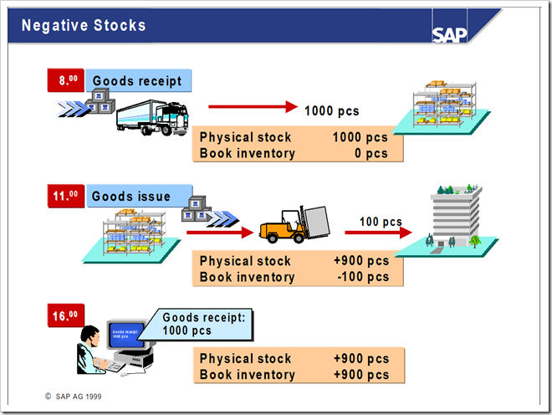
- You can also manage negative stock balances for materials with moving average price control and for special stocks, such as vendor consignment, material provided to vendor, sales order stock, and project stock.
- Negative stock balances are required if, for organizational reasons, goods issues are entered before the corresponding goods receipts, and the material is already physically located in the warehouse.
- Once you have posted the goods receipts, the book inventory balance should correspond with the physical stock again – in other words, it should no longer be negative. Negative stocks always indicate that physical movements have to be entered in the system at a later stage.
- If you work with negative stock balances, you have to ensure that you do not have negative stocks on the balance sheet key date or when you carry out a physical inventory.
- As of Release 4.6A, blocked stock can also be negative.
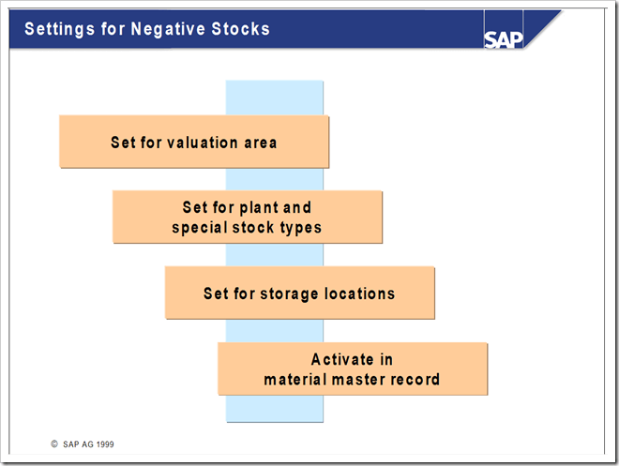
- To work with negative stock balances, you have to allow these for the relevant valuation area and storage locations in Customizing for Inventory Management.
- You make the settings for negative stocks in Customizing for Inventory Management by choosing Inventory Management? Goods Issue / Transfer Postings? Allow Negative Stocks.
- If the first movement of a material is an outward movement, you can define in Customizing that storage location data is created automatically for goods issues by choosing Create Storage Location Automatically.
1.在後台中設置工廠允許負庫存標記，並設置哪個庫存地允許負庫存(T-CODE:OMJ1)。
IMG。物料管理。存貨管理和盤點。發貨 / 移轉過帳。允許負庫存
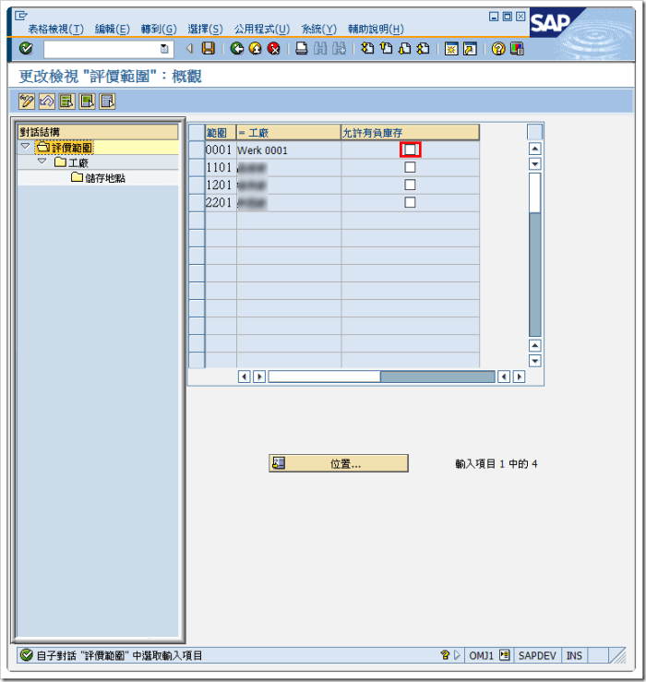
- 設定那些特殊庫存可以有負庫存
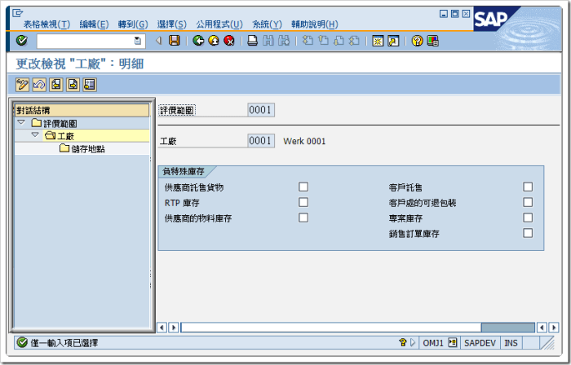
- 設定那個儲位可以使用負庫存
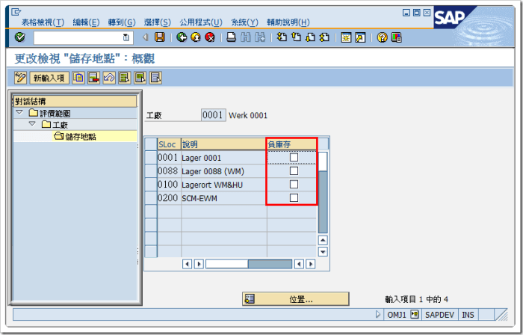
2.在物料主數據工廠存儲視圖中選擇「允許負庫存」標記(T-CODE:MM02)。
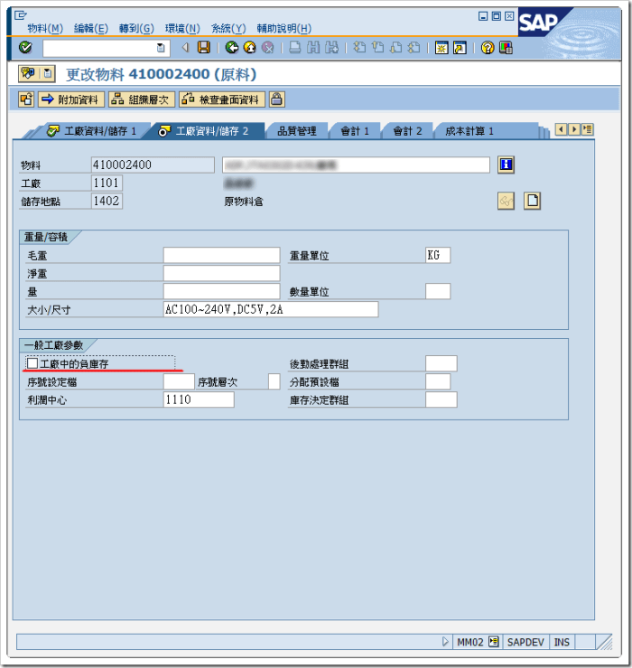
注意！「工廠」及「儲存地點」都要輸入才能使用負庫存(特殊庫存不需要儲存地點)

