Restore PRD DB to QAS

系統資訊

Device File Size
PRD
DB 320 GB (Free 17 GB)
Log 35 GB
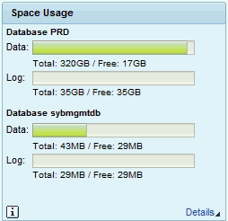
QAS
DB 357 GB (Free 53 GB)
Log 35 GB
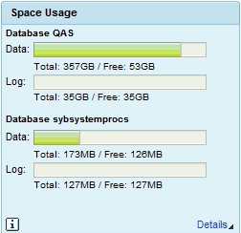

準備工作

執行 PRD 備份

sapprd\qasadm>
sapqas\prdadm>
sapsa , database account

dump database PRD to '${dmp1}' stripe on '${dmp2}' stripe on '${dmp3}' stripe on '${dmp4}' with verify=header, compression=101, blocksize=2097152

sybqas 複製檔案到qas , 執行restore

Sybase Restore

關閉QAS SAP，重開 Sybase
root #> su - qasadm
qasadm #> stopsap
qasadm #> startsap db
qasadm #> exit

以PRD備份檔還原QAS
21:25 ~ 21:55 => 00:30
root #> su - sybqas
sybqas #> isql -SQAS -Usapsa -X
iSQL> use master
iSQL> load database QAS from '/sybase/backups/PRD_full-20180721-1_1.dmp' stripe on '/sybase/backups/PRD_full-20180721-1_2.dmp' stripe on '/sybase/backups/PRD_full-20180721-1_3.dmp' stripe on '/sybase/backups/PRD_full-20180721-1_4.dmp'
iSQL> online database QAS

SAP 調整

刪除SAP參數檔
root #> su - sybqas
sybqas #> isql -SQAS -Usapsa -X
iSQL> use QAS
iSQL> delete from SAPSR3.TPFET
iSQL> delete from SAPSR3.TPFHT
iSQL> exit

安裝License Key

d:\usr\sap\QAS\SYS\profile

取得hardware key (E1452740397) , 是用來上sap網站上申請licences key，申請一次可用一年。

saplikey pf=DEFAULT.PFL -get ( hardward key)

root #> su - qasadm
qasadm #> cd /sapmnt/QAS/profile
qasadm #> saplikey pf=QAS_DVEBMGS00_SAPQAS -show 查出目前的licences , 並刪除
qasadm #> saplikey pf=QAS_DVEBMGS00_SAPQAS -delete PRD N0254116226 NetWeaver_SYB
qasadm #> saplikey pf=QAS_DVEBMGS00_SAPQAS -delete PRD N0254116226 Maintenance_SYB
qasadm #> saplikey pf=QAS_DVEBMGS00_SAPQAS -install QAS.txt
qasadm #> saplikey pf=QAS_DVEBMGS00_SAPQAS -show

上網取得licences key

停用SAP

停用QAS Background Work Process
qasadm #> grep btc * " btc mark掉
qasadm #> vi QAS_DVEBMGS00_SAPQAS

啟動SAP
停止Background Job
SM37 , 停止排程背景程式

關閉SAP
啟用Background Work Process
qasadm #> cd /sapmnt/QAS/profile
qasadm #> vi QAS_DVEBMGS00_BWSAPQAS
" btc mark掉的還原

啟動SAP

[RZ10] 匯入SAP參數檔

[SICK] 進行一致性檢查

[SE06] Reset Transport Configuration , (DEV 000)
初使化STMS，DDIC 19920706

[STMS] Join Transport Domain , (DEV 000)

需要 transport controller PRD client 000 DDIC 密碼
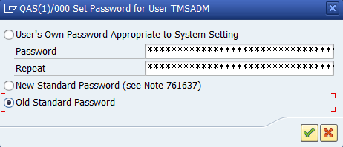

[PRD:STMS] Distribute Transport Route Configuration, (QAS 00)
Change, Save

[RZ12] 建立RFC Server Group
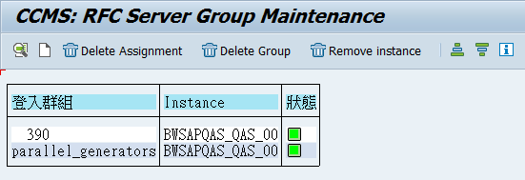

[RZ04] 重建Operation Mode
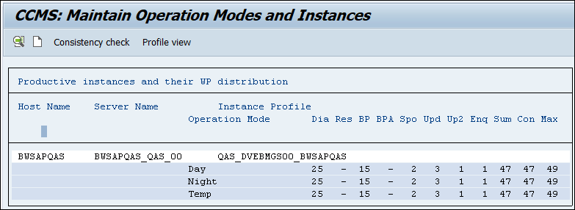

[SM36] 排程Standard Job

[SE38] 排程Transport Job (RDDNEWPP)

[DBCO] 調整DBCO
設定 sapsa 的密碼為原來 QAS sapsa 的密碼
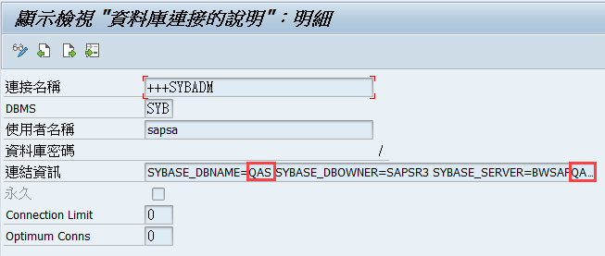
Test: ADBC_TEST_CONNECTION

[BDLS] 變更邏輯系統
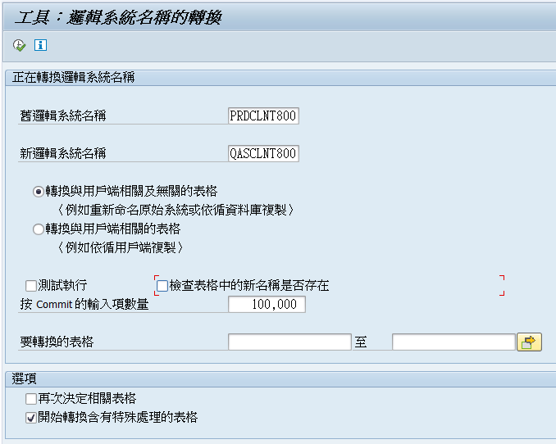

[SCC4] 調整Client設定
測試環境
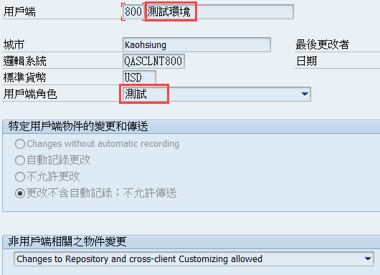

[SE61] 調整登入畫面訊息 , 選TX ,
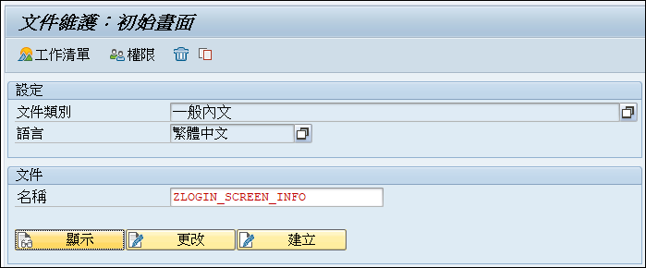
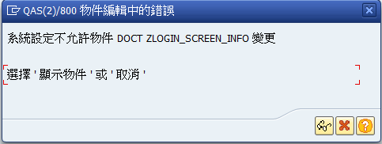

TCode SE06
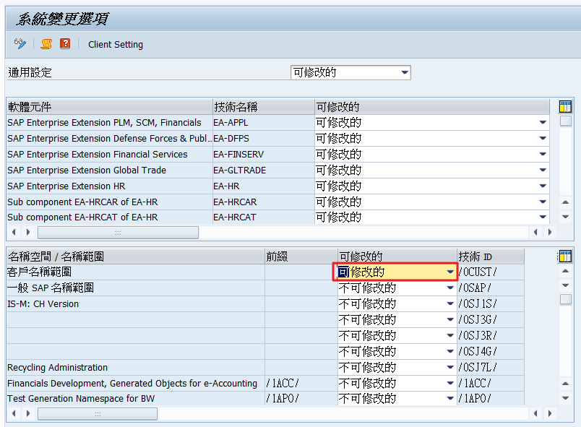

不修改 改 可修改
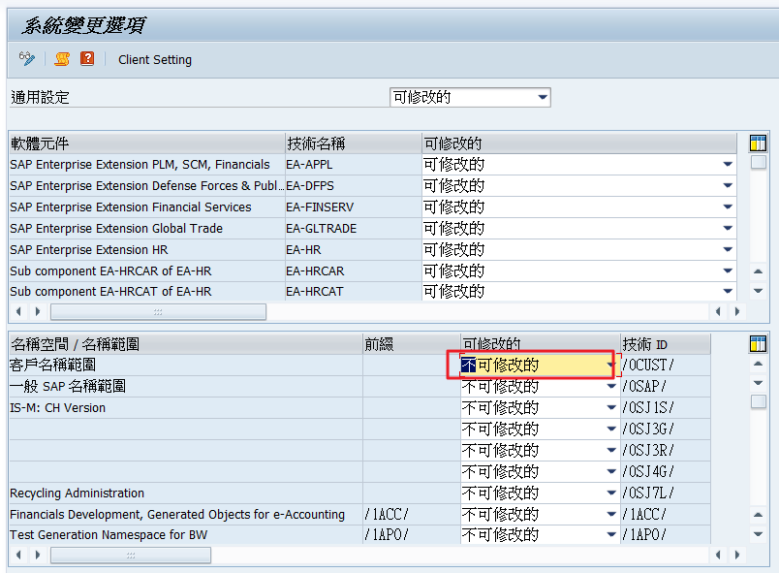

做到這裡就行了

[SPAD] 調整列印佇列伺服器 (不用調)
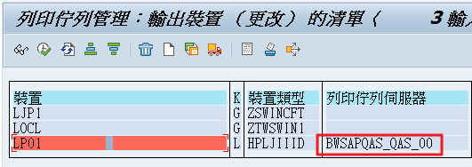

[SECSTORE] Check Secure Storage (全部綠燈不用調)
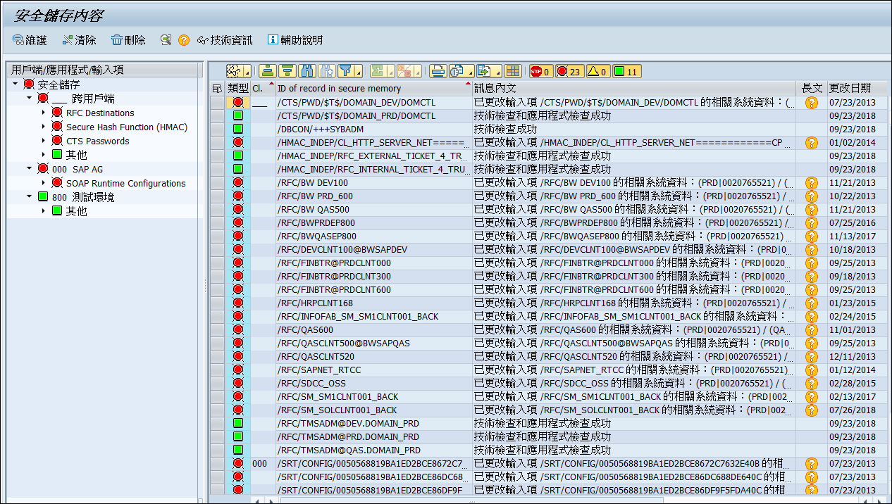

[SE38] Update Secure Storage (不用做)
建立程式: Z_NOTE_1922423
標題: Generator for Migration Keys for the Secure Storage ABAP/DB
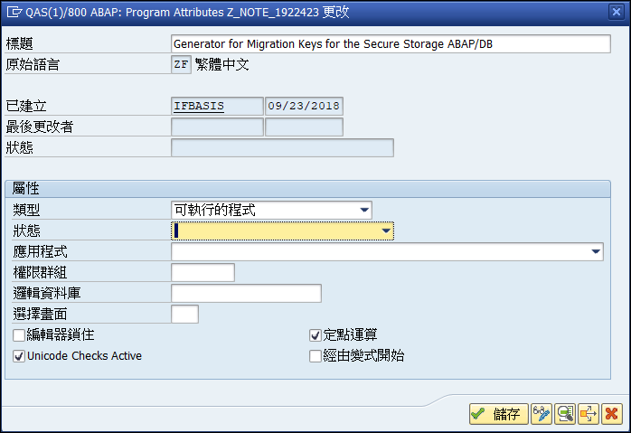

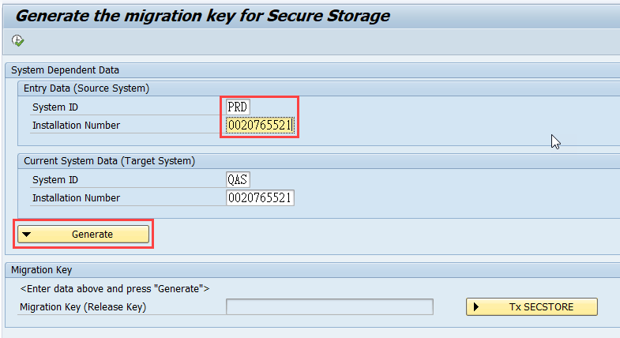
執行程式: Z_NOTE_1922423
Source System
System ID: PRD
Installation Number: (與 target system 相同)

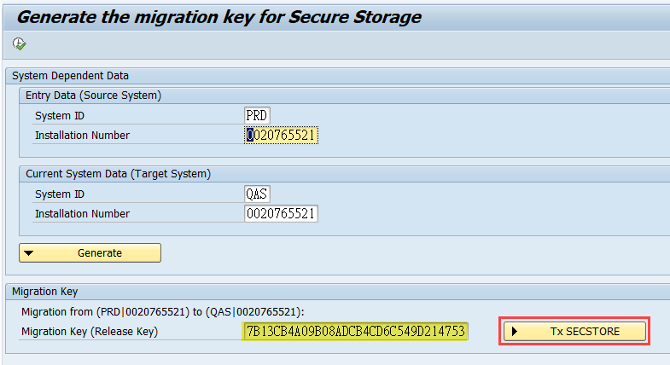

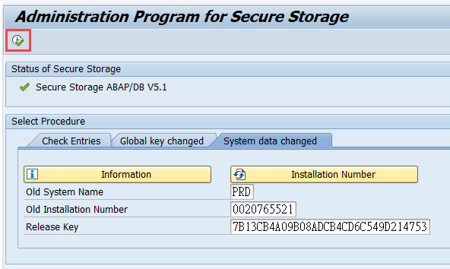

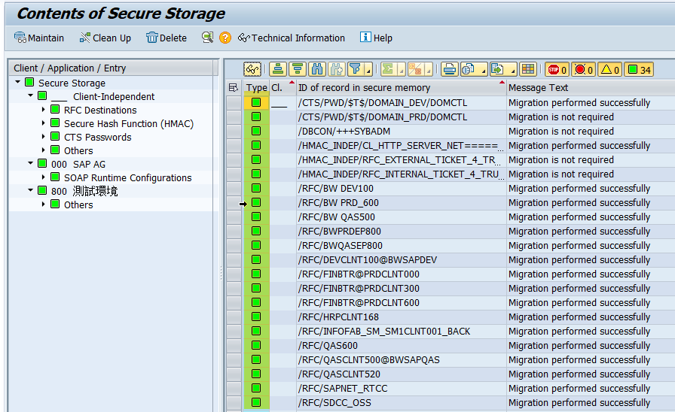

開放使用

刪除備份檔案

