Restore PRD DB to QAS

系統資訊

Device File Size
PRD
DB 320 GB (Free 17 GB)
Log 35 GB
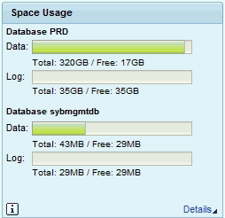
QAS
DB 357 GB (Free 53 GB)
Log 35 GB
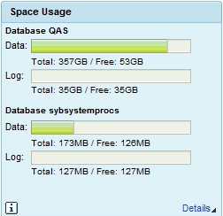

準備工作

執行 PRD 備份
20:39 ~ 21:20 => 0:41 (含備份檔複製)
root #> su - sybprd
sybprd #> cd ../backups
sybprd #> ll
檢查是否有舊的備份

sybprd #> cd ../PRD/sh
sybprd #> ./bk_syscp.sh (備份完會自動複製備份檔到 QAS)
dump database PRD to '${dmp1}' stripe on '${dmp2}' stripe on '${dmp3}' stripe on '${dmp4}' with verify=header, compression=101, blocksize=2097152

執行QAS備份
17:53 ~ =>
root #> su - sybqas
sybqas #> cd ../backups
sybqas #> ll
檢查是否有舊的備份

sybqas #> cd ../QAS/sh
sybqas #> ./bk_syscp.sh

Sybase Restore

關閉QAS SAP，重開 Sybase
root #> su - qasadm
qasadm #> stopsap
qasadm #> startsap db
qasadm #> exit

以PRD備份檔還原QAS
21:25 ~ 21:55 => 00:30
root #> su - sybqas
sybqas #> isql -SQAS -Usapsa -X
iSQL> use master
iSQL> load database QAS from '/sybase/backups/PRD_full-20180721-1_1.dmp' stripe on '/sybase/backups/PRD_full-20180721-1_2.dmp' stripe on '/sybase/backups/PRD_full-20180721-1_3.dmp' stripe on '/sybase/backups/PRD_full-20180721-1_4.dmp'
iSQL> online database QAS

SAP 調整

刪除SAP參數檔
root #> su - sybqas
sybqas #> isql -SQAS -Usapsa -X
iSQL> use QAS
iSQL> delete from SAPSR3.TPFET
iSQL> delete from SAPSR3.TPFHT
iSQL> exit

安裝License Key

d:\usr\sap\QAS\SYS\profile

取得machine key
saplikey pf=DEFAULT.PFL -get

root #> su - qasadm
qasadm #> cd /sapmnt/QAS/profile
qasadm #> saplikey pf=QAS_DVEBMGS00_BWSAPQAS -delete PRD N0254116226 NetWeaver_SYB
qasadm #> saplikey pf=QAS_DVEBMGS00_BWSAPQAS -delete PRD N0254116226 Maintenance_SYB
qasadm #> saplikey pf=QAS_DVEBMGS00_BWSAPQAS -show
qasadm #> saplikey pf=QAS_DVEBMGS00_BWSAPQAS -install QAS.txt
qasadm #> saplikey pf=QAS_DVEBMGS00_BWSAPQAS -show

停用QAS Background Work Process
qasadm #> grep btc * " btc mark掉
qasadm #> vi QAS_DVEBMGS00_BWSAPQAS

啟動SAP

停止Background Job
SM37 , 停止排程背景程式

關閉SAP

啟用Background Work Process
qasadm #> cd /sapmnt/QAS/profile
qasadm #> vi QAS_DVEBMGS00_BWSAPQAS

啟動SAP

[RZ10] 匯入SAP參數檔

[SICK] 進行一致性檢查

[SE06] Reset Transport Configuration , (QAS 000)
初使化STMS

[STMS] Join Transport Domain , (DEV 000)

需要 transport controller PRD client 000 DDIC 密碼
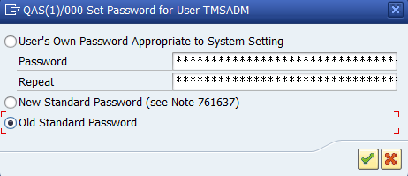

[PRD:STMS] Distribute Transport Route Configuration, (QAS 00)
Change, Save

[RZ12] 建立RFC Server Group
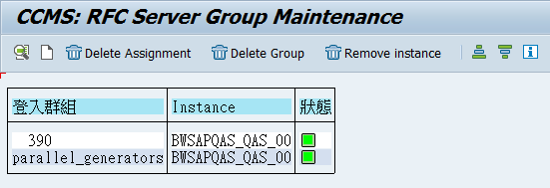

[RZ04] 重建Operation Mode
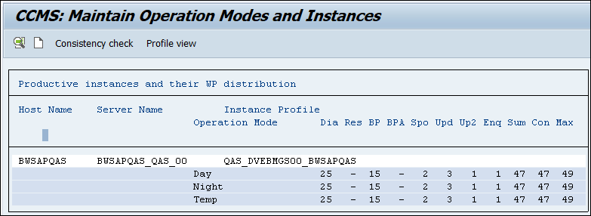

[SM36] 排程Standard Job

[SE38] 排程Transport Job (RDDNEWPP)

[DBCO] 調整DBCO
設定 sapsa 的密碼為原來 QAS sapsa 的密碼
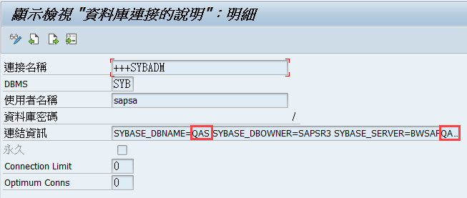
Test: ADBC_TEST_CONNECTION

[BDLS] 變更邏輯系統
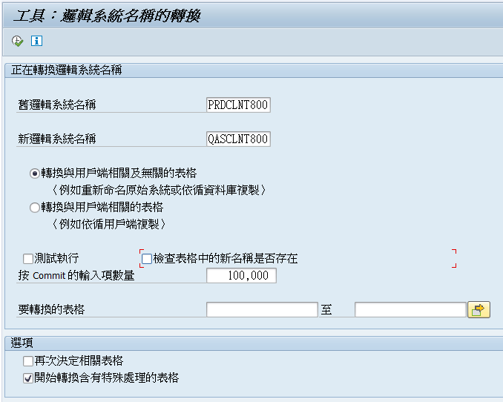

[SCC4] 調整Client設定
測試環境
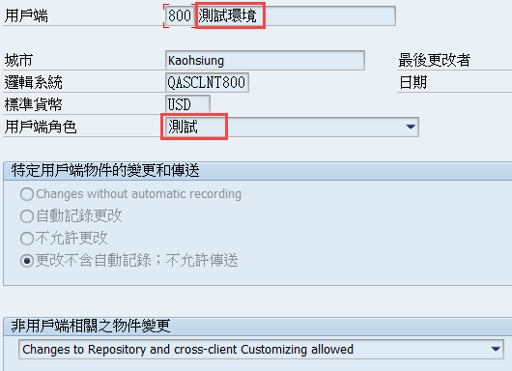

[SE61] 調整登入畫面訊息 , 選TX ,
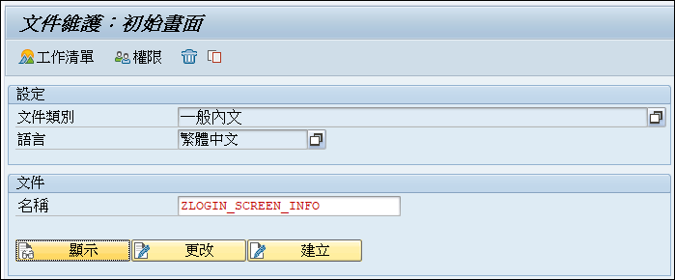
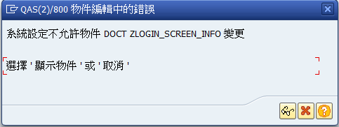

TCode SE06
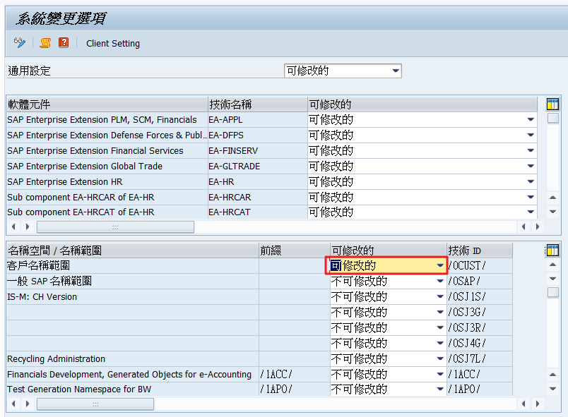

@0S@SAP QAS System:
@5B@ 800 ----- 測試環境 (資料更新: 2018/09/22)

不修改 改 可修改
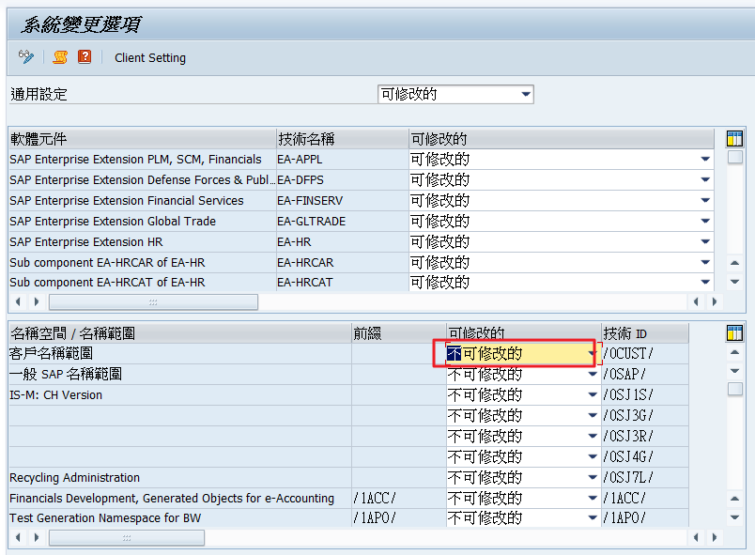

[SPAD] 調整列印佇列伺服器
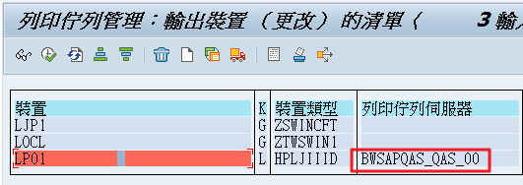

[SECSTORE] Check Secure Storage
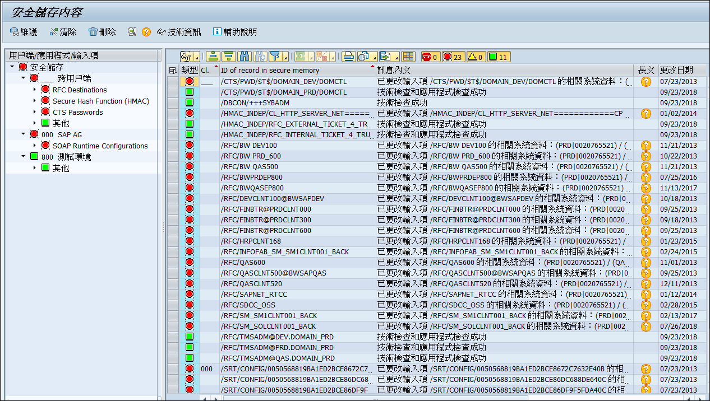

[SE38] Update Secure Storage
建立程式: Z_NOTE_1922423
標題: Generator for Migration Keys for the Secure Storage ABAP/DB
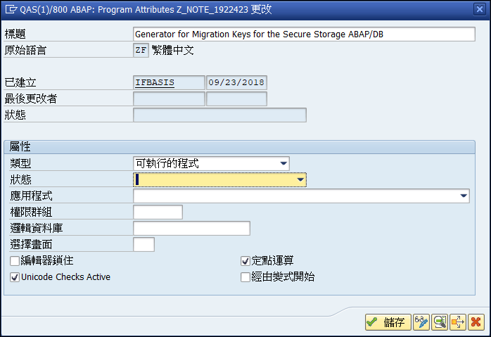

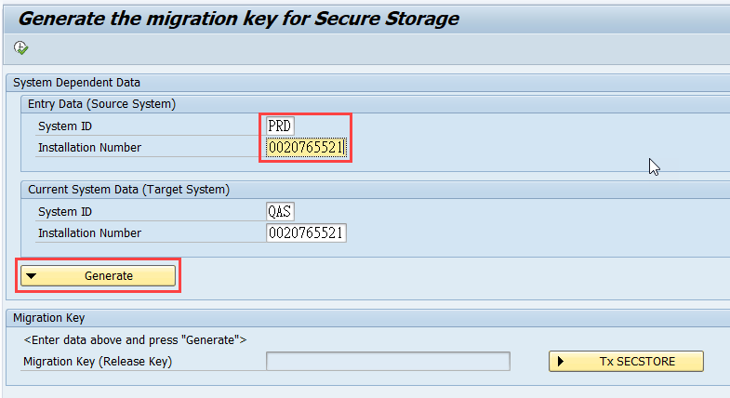
執行程式: Z_NOTE_1922423
Source System
System ID: PRD
Installation Number: (與 target system 相同)

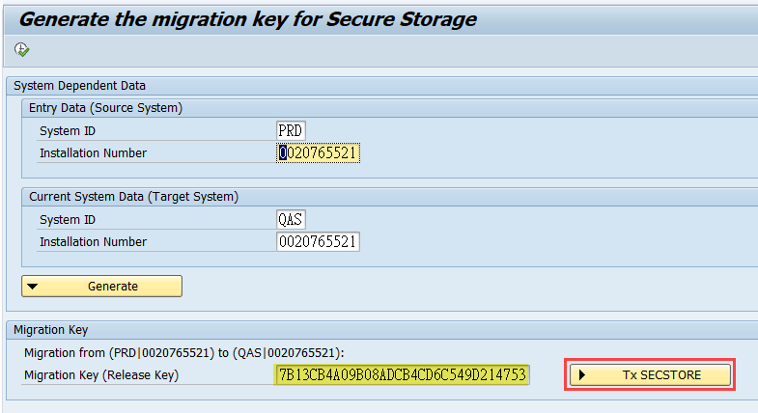

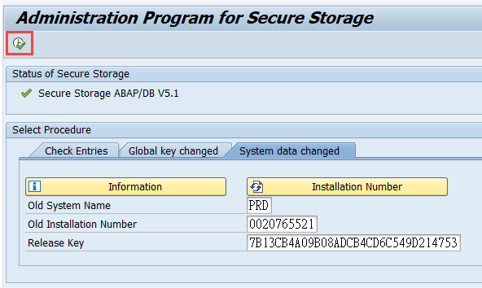

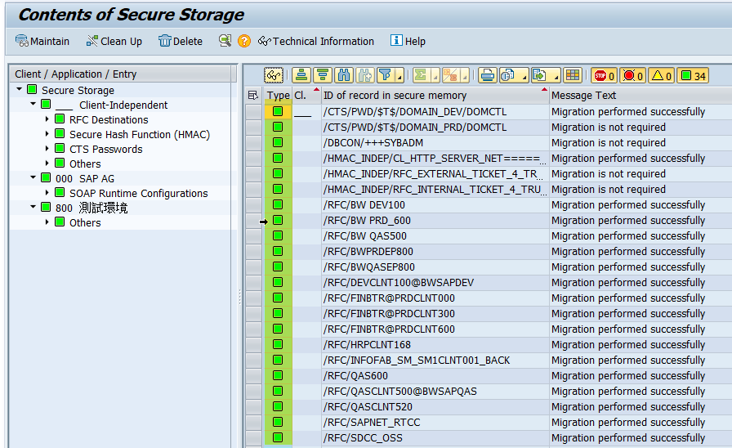

開放使用

刪除備份檔案

